**Contents**

* + 1. Introduction
    2. Objectives
    3. E/R Diagram
    4. Relational Schema
    5. Database design
    6. SQL queries
    7. Conclusion

**1. Introduction**

The main purpose of YBS reservation system is to ride quickly and travel easily for user in Yangon. The user cannot be wrong when they ride an YBS. To use this system, they require mobile phone. The system needs to include the way, number of bus, what color arrive what places and price per once. It also needs to create tables, E-R diagram, relational schema, database design, SQL constraint for building database. This system is also used for admin to change easily so that the system is more update.

**2. Objectives**

This system can be used for passengers:

* To know the way where they want to go.
* To know the number of bus that they must ride.
* To know the information about YBS system easily as they just have a phone.
* To ride comfortably and easily from one place to the other.
* To lower the time to prepare for riding the bus
* Not to confuse about YBS system.

**3. E/R Diagram**

Runs _On

Bus Stop

Period

Route

YBS BUS

Driver

Path

1 M

drives

M N

N

1

N

Fig: E/R Diagram of YBS reservation system

**4. Relational Schema**

* DRIVER(DID,DNAME,ADDRESS,PHONE)
* PERIOD(BID,BSID,PERIOD)
* BUS_STOP(BSID,BNAME)
* YBSBUS(BID,BCOLOR,MAX_SEATS)
* ROUTE(RID,RCOLOR,RNAME)
* PATH(PID,FROM_PATH,TO_PATH)
* RUNS_ON(BID,RID,PID)

|  |
| --- |
| PERIOD TABLE |
| BID PK/FK  BSID PK/FK  PERIOD |

|  |
| --- |
| RUNS_ON TABLE |
| BID PK/FK  RID PK/FK  PID PK/FK |

5. Database Design

|  |
| --- |
| DRIVER TABLE |
| DID PK  DNAME  ADDRESS |

|  |
| --- |
| YBSBUS TABLE |
| BID PK  BCOLOR  MAX_SEATS  DRIVER FK |

|  |
| --- |
| BUS_STOP TABLE |
| BSID PK  BSNAME  RID FK |

|  |
| --- |
| PATH TABLE |
| PID PK  FROM_PATH  TO_PATH |

|  |
| --- |
| ROUTE TABLE |
| RID PK  RCOLOR  RNAME |

Fig: Database design of YBS reservation system

**6. SQL Queries**

Q1…Get the bus number that runs on the same path ‘Hlegu’.

Answer:

SELECT BID

FROM RUNS_ON

WHERE PID IN

(SELECT PID

FROM PATH WHERE FROM_PATH ='Hlegu');

Output table:

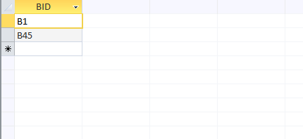

Q2… Get the route name and route color for route number ‘R4’.

Answer:

SELECT RCOLOR, RNAME

FROM ROUTE

WHERE RID='R4';

Output table:

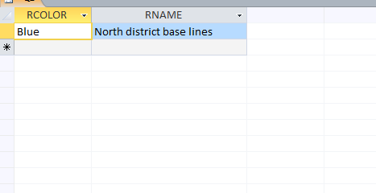

Q3..Get the driver id and name who live in the address ‘Dagon (South)’.

Answer:

SELECT DRIVER.DID, DNAME

FROM DRIVER

WHERE ADDRESS=‘Dagon (south)';

Output table:

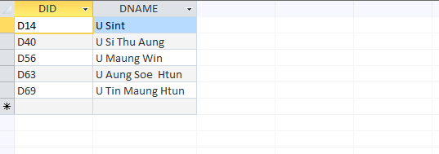

Q4….Get the bus car id that have the same route color ‘red’.

Answer:

SELECT BID

FROM YBSBUS

WHERE BID IN

(SELECT BID

FROM RUNS_ON

WHERE RID IN

(SELECT RID

FROM ROUTE

WHERE RCOLOR='red'));

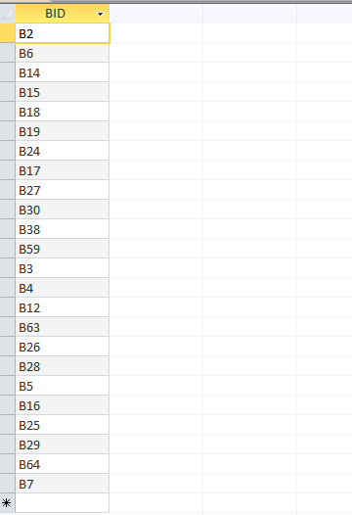

Q5…Get the from and to path for bus car that have the route color blue.

Answer:

SELECT FROM_PATH, TO_PATH

FROM PATH

WHERE PID IN

(SELECT PID

FROM RUNS_ON

WHERE RID IN

(SELECT RID

FROM ROUTE

WHERE RCOLOR='blue'));

Output table:

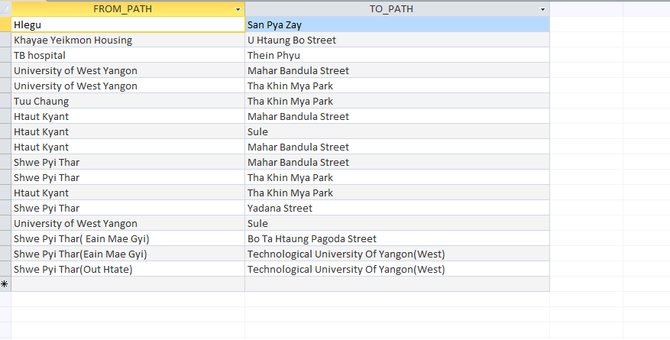

Q6….Get the driver name who drives the bus car has the color ‘Green’.

Answer:

SELECT DNAME

FROM DRIVER

WHERE DID IN

(SELECT DRIVER

FROM YBSBUS

WHERE BCOLOR='R5');

Output table:

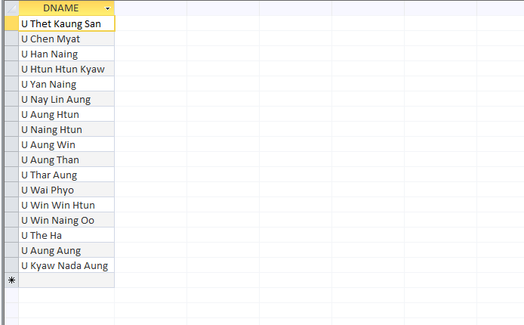

Q7…Get the form_path for bus car that have bus number ‘B32’.

Answer:

SELECT FROM_PATH

FROM PATH

WHERE PID IN

(SELECT PID

FROM RUNS_ON

WHERE BID='B32');

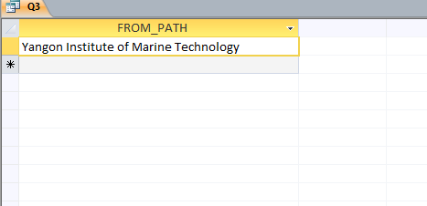

**7.Conclusion**  
  
The database design of the YBS Reservation System is a paradise for passenger. It helps passenger to ride the correct path and know the car color. And then, they know again what car color runs on what route. So passenger can ride the bus correctly and safely.

YBS  
(Yangon Bus Service)  
ႏွင့္  
ရန္ကုန္ၿမိဳ့ကိုပတ္ၾကစို့  
  
(လိုရာခရီးေရာက္ရွိဖို့ ၀ိုင္း၀န္းကူညီေဆာင္ရြက္စို့)